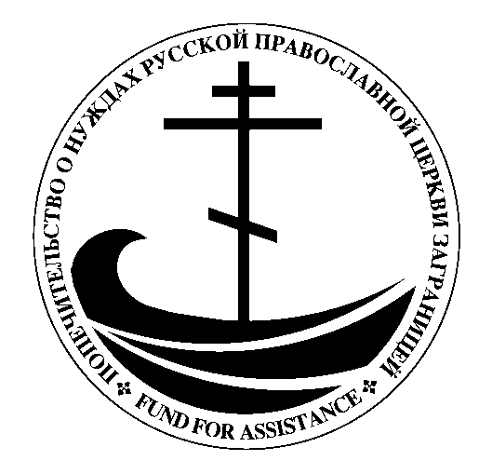
August 2019
Fund for Assistance to the
Russian Orthodox Church Outside of Russia
Попечительский Фонд о Нуждах
Русской Православной Церкви Заграницей

Dear <First Name,>

I am writing to you because I believe Fr. Rafael Gonzalez is a priest entirely devoted to his parishioners and will literally go the distance to make sure they have everything they need, even if it means picking them up himself and taking them to church.

Where is this priest located you may ask?

The Dominican Republic.

In a country known as a vacation spot, you may not think it's possible to perhaps even seek the truth of Orthodoxy...but I can tell you it's true.

I will tell you more about how the people of the Dominican Republic are seeking Orthodoxy. But first, I want to show you how you can unite the Orthodox all over the Dominican Republic.

You have a unique opportunity to help the Dominican people. How do they need your help? They need a van.

Why do they need a new van? Let me tell you the history of how Fr. Rafael, the only canonical Russian priest serving in the Dominican Republic, got the old van he is currently using today.

"Fr. Rafael, please come quickly, I want you to take my confession, I am dying." The words were spoken over the telephone by an elderly parishioner, Vladimir, who was sick with cancer. Fr. Rafael rushed to find transportation to get to his dying parishioner.

He did not make it.

Unfortunately, Fr. Rafael did not have his own transportation to get to him. "Go back home, he already died," said Lena, Vladimir's wife. (Can you imagine?!). Scrambling to find transportation, Fr. Rafael was too late.

Thankfully, at the time a kind-hearted parishioner was able to step in and buy a used van for batushka to help serve the people of the Dominican Republic. But that was 10 years ago. Now the car is old and on its last legs; the parish cannot afford to buy another van.

Please help Fr. Rafael make sure that a lack of transportation isn't a reason another dying man misses his last confession.

Before Vladimir died, he told his wife he wanted to be buried in the cemetery nearest to where Fr. Rafael was living so he could regularly pray for him.

Fr. Rafael has fulfilled Vladimir's dying wish. For the last 10 years, he has lovingly gone every month to clean up the gravesites and serve a panihida for Vladimir and 12 other Orthodox now buried there.

"They're my children, I have to take care of them," he says simply. This is the type of devoted priest Fr. Rafael is. However, the used van Fr. Rafael received after Vladimir's death is nearly 20 years old and on the verge of breaking down.

Our resources are thin right now and I could sure use your help! Fr. Rafael needs $25K for a new van.

Your kind-hearted gift will enable Fr. Rafael not only to drive to emergencies like the one with Vladimir but to also serve the five Orthodoxy communities of the Dominican Republic.

Fr. Rafael's home base is the location in Costambar, Province of Puerto Plato, where he serves a parish of 56 people. From Costambar he travels to Susúa, Jamao, Santo Domingo, and even Punta Cana, 8 hours from his home! (See what I mean about him going the distance?! Literally!).

And with your help of a new van, Fr. Rafael will be able to continue his long hours in the car to baptize, commune, and bring spiritual comfort to his parishioners. Your generosity will be responsible for uniting the Dominican people in Orthodoxy.

An exciting part of funding this new van, for Fr. Rafael, is that he will be able to continue his missionary work. When people come to Fr. Rafael seeking the truth of Orthodoxy he guides them through their first steps towards Christ.

Those seeking Orthodoxy come back to Fr. Rafael for more: to learn about Orthodoxy, help in the Church, and eventually to receive confession, baptism, and even marriage within the Church. Fr. Rafael has already baptized 240 and married 73 couples!

Imagine what a relief it would be for Fr. Rafael and his parishioners knowing that he is not hindered by unreliable transportation. Fr. Rafael won't have to worry about missing someone's last confession and being unable to confess, commune, and minister to his parishioners.

That's why I hope you can make a donation today. The people in the Dominican Republic need you. Will you help?

And they need the van now. It is very dangerous to drive the distances Fr. Rafael does with an unreliable van.

I know you're someone who cares about your fellow Orthodox brothers and sisters in Christ. You're also one of those generous people is ready to give above and beyond.
"He that hath pity upon the poor lendeth unto the LORD; and that which he hath given will he pay him again." Proverbs 19:17.

If you help me collect $25K, Fr. Rafael will be able to buy the van that he needs to continue serving the Orthodox in the Dominican Republic.

Fr. Rafael needs a van with 12 seats so that he can pick up parishioners without cars and take them to church services, organize various events like Russian Culture Days, soccer competition for the kids, to transport large items for church, and so on. Father found a very economical van. It consumes less fuel than a conventional 5 passenger car.

Will you help him continue with his mission work today?

If you send your donation now, you will ensure that Fr. Rafael has a reliable vehicle to drive to continue his missionary work.

Transportation is fundamental to be able to effectively fulfill the missionary work and attend Russian communities dispersed across the country. That's why I hope you can make a donation now.

You will demonstrate real Christian love for your fellow Orthodox Christians. May God bless you abundantly for your generosity!

In short, with the car on the verge of collapse, the need is great. Please hurry so Fr. Rafael can continue serving the needs of "his [spiritual] children".

With much love in Christ,

Mark Selawry
Fund for Assistance to ROCOR
President

P.S. I am hoping to let Fr. Rafael know that thanks to your gift he can buy a van by Nativity of the Theotokos (September 8/21) so he can continue serving and not miss another emergency. Please send a gift today.

P.P.S. If you can’t send your donation by this deadline, please call us at
(917) 817-2925 if you’d like to still get it in by that time. Thank you.

